**Week 2 – Hands-on : Mockito Exercises**

Exercise 1 : Mocking and Stubbing

First we add the dependencies for Mockito, Junit5 to pom.xml

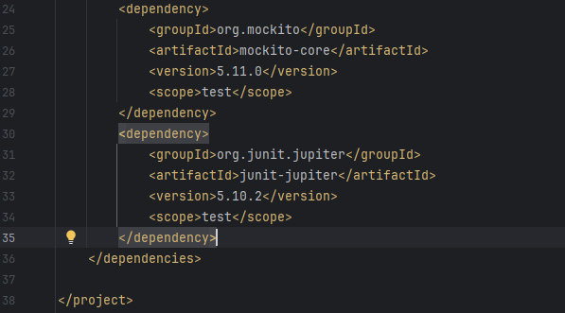

We create class “ExternalApi.java”

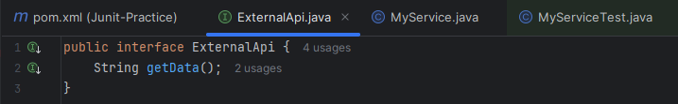

Then we create class “MyService.java”

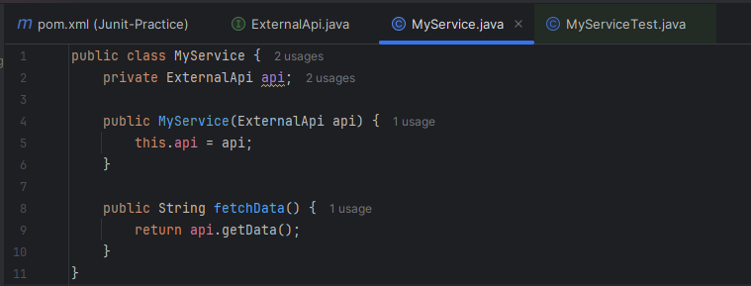

After that we’ll create MyServiceTest.java

**SOLUTION :**

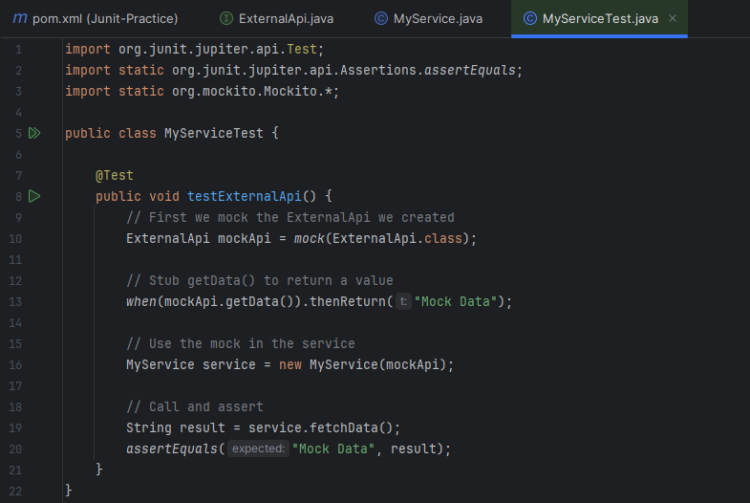

**OUTPUT :**

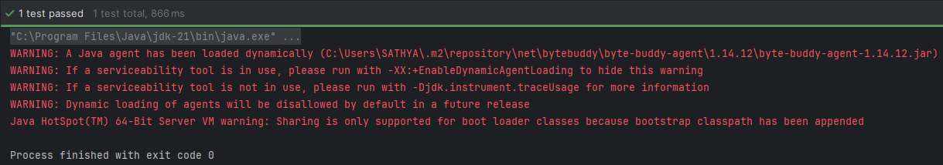

Test passed successfully, the warnings we get are harmless and fixing isn’t necessary.

Exercise 2 : Verifying Interactions

We already have classes “ExternalApi.java” and “MyService.java” so we’ll just modify the test class “MyServiceTest.java”

**SOLUTION :**

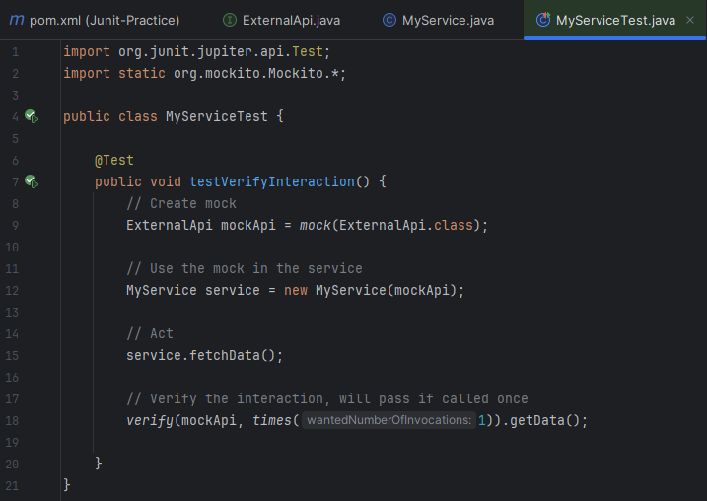

**OUTPUT :**

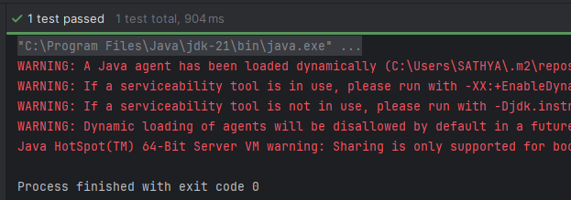

Test passed successfully, the warnings we get are harmless and fixing isn’t necessary.